26.12.10 Editors - Properties Editor - Object Data Properties Tab - Empty&Image Object
Detailed table of content 1
Empty panel 2
Display As 2
Image panel 4
Image property 4
Source 4
Custom Properties Panel 7
Add 8
Edit 8
Remove 8

Detailed table of content
Detailed table of content
Detailed table of content 1
Empty panel 2
Display As 2
Size 2
Image 2
Offset X, Y 3
Depth 3
Default 3
Front 3
Back 3
Side 3
Both 3
Front 3
Back 3
Show in 3
Orthographic 3
Perspective 3
Only Axis Aligned 3
Transparency 3
Opacity 3
Image panel 4
Image property 4
Image Browser 4
Open 4
Name 4
Fake User 4
Open Image 4
Source 4
Source Type Single Image 4
Path edit box 4
Pack 4
Path edit box 4
Open 5
Refresh 5
Color Space 5
Source Type Movie + Image Sequence 5
Path edit box 5
Pack 5
Path edit box 5
Open 5
Refresh 5
Info string 5
Frames 6
Start 6
Offset 6
Cyclic 6
Auto Refresh 6
Color Space 6
Source Type Generated 6
X / Y 6
Float Buffer 6
Generated Type Blank 6
Color 6
Generated Type UV Grid 7
Generated Type Color Grid 7
Color Space 7
Source Type Udim 7
Custom Properties Panel 7
Add 8
Edit 8
Remove 8

Empty panel
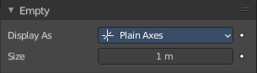
Empties are objects without additional geometry. They do not render. A use case is that you use empties as handlers for a rigged character.

Display As
Empties have graphical elements to display the location. In this drop down list you can choose the shape of this graphical element.
Further display settings can be found in the Object Properties tab in the Viewport Display panel.

Size
The size of the graphical element.

Image
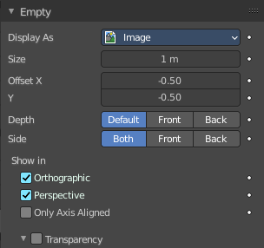
Empties can display images. This images can be used to create reference images to model along. The image is always displayed, independent of the 3D display mode.

Offset X, Y
Offset the image origin. 1.0 represents the width/height of the image.

Depth

Default
Use normal depth behavior.

Front
Always display on top of other objects.

Back
Always display behind of other objects.

Side

Both
Display both the front and back of the empty.

Front
Only display the front of the image.

Back
Only display the back of the image.

Show in

Orthographic
Show in orthographic view.

Perspective
Show in perspective view.

Only Axis Aligned
Only displays the image contents when the view is aligned with the object’s local axis.

Transparency
Use alpha blending instead of alpha-test. The image then blends with the background but can have depth sorting artifacts.

Opacity
The opacity.

Image panel

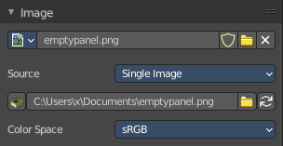
When you choose an empty of type Image then this panel with further settings appears.

Image property

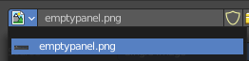
Image Browser
A list of available images in the scene.

Open
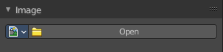
When no image is loaded the open button is displayed. Open an image opens the file browser to load an image.

Name
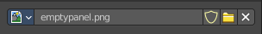
The name of the currently active image.

Fake User
Keep this image in the scene even if it has no user.

Open Image
Open image opens the file browser to load an image.

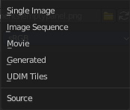
Source
What image type to choose.

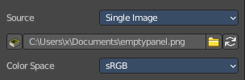
Source Type Single Image

Path edit box

Pack
With this button you can pack the movie or the image sequence into the blend file. It gets packed when you save the blend file the next time.

Path edit box
See and edit the path to your movie or image sequence files.

Open
Open a new movie or image sequence files. A file dialog will appear.

Refresh
Reread the movie or image sequence files.


Color Space
Choose the color space type for the movie or image sequence files.

Source Type Movie + Image Sequence
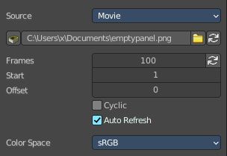
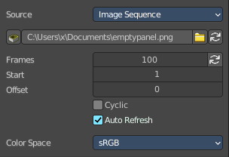


Path edit box

Pack
With this button you can pack the movie or the image sequence into the blend file. It gets packed when you save the blend file the next time.

Path edit box
See and edit the path to your movie or image sequence files.

Open
Open a new movie or image sequence files. A file dialog will appear.

Refresh
Reread the movie or image sequence files.

Info string
Some information about the currently loaded movie. Frames, resolution and color space.

Frames
The number of frames of the movie or image sequence.

Start
The start frame of the movie or image sequence

Offset
Offset the number of the frame to use in the animation. -1 means off.

Cyclic
Cycle the images in the movie.

Auto Refresh
Always refresh image on frame changes.


Color Space
Choose the color space type for the movie or image sequence files.

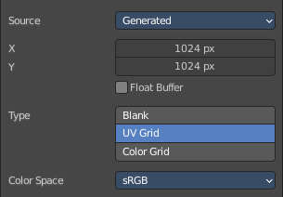
Source Type Generated

X / Y
The image width and height.

Float Buffer
Use a floating point buffer. 8 Bit images uses integers. 32 Bit works with floats.


Generated Type Blank
This type displays an image with one blank color.

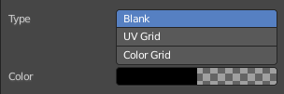
Color
The color of the blank image.


Generated Type UV Grid
This type displays a with a black and white checker texture but colored dots.


Generated Type Color Grid
This type displays a with a colored checker texture with numbers.


Color Space
Choose the color space type for the image.

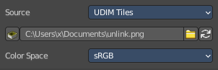
Source Type Udim
UDIM is an enhancement to the UV mapping and texturing workflow. And does not belong here. But in the UV Editor. It is just in the list because it shares the same menus with the UV Editor.
You can load a UDIM file. But it will just display the first tile of the UDIM image. And there is no way to adjust the UDIM settings since they are in the UV Editor, in Edit mode. And Empties have no Edit mode.

Custom Properties Panel


Here you can define custom properties that can be used for scripting.

Here you might also find custom properties from addons or scripts.

Add
Adds a new property.


Edit
Opens a panel where you can adjust the settings for the custom property.

Remove
Removes the property.

